**COMSATS UNIVERSITY, ISLAMABAD**

**Department of Computer Science**

**Lab Midterm Examination, Fall-2022**

**Course: Database Systems - I (CSC371) Class:**

**Instructor: ____________________ Total Marks: 25**

**Instructions:**

**1- This is a take-home task.**

**2- You need to submit the solution for each of the parts in a well-formatted document.**

**[CLO5] Apply data processing operations on both relational and non-relational DBMS.**

**Part-I:** Given the EER diagram, create the same using a modeling tool of your choice. (Oracle’s Data Modeler tool is preferred). **[2]**

**Part-II:** Export the DDL script, corresponding to the relational schema of the EERD created in Part-I, to Oracle Database System. **[2]**

**Part-III:** Implement the EER constraints 1-1, 1-many, many to many, “U”, “O”, “d”, “Partial participation”, “Total participation” , multi-attribute, super-class, sub-class, multiple-inheritance ( Can Java language ). **[8]**

**Part-IV:** Insert a few meaningful tuples in the resultant relations **[3]**

**Part-V:** Now in this part, you are going to first create a meaningful query in English and then in SQL for each of the following situations:

* Think of a need that will require joining at least 3 tables. **[3]**
* Think of a need that will require the use of join with grouping and aggregation. **[3]**
* Think of a need that involves the use of a sub-query. **[2]**
* Think of a need that involves the need of using any of the set operators. **[2]**

Evaluation Criteria You will initially be evaluated using the marking criteria defined above against each of the tasks. After the submission, a viva voce will be conducted to evaluate your understanding of the submitted solution. The following percentages will then be applied on top of the marks obtained to determine the final marks;

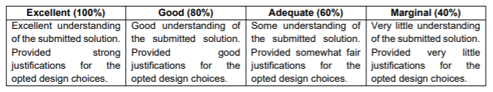

For example, if you obtain 20 marks out of 25 based on your submitted solution, and then during viva if you only have marginal understating of it, you will eventually get 20*40% = 8 marks out of 25.

